### Internal Medicine, Cardiovascular Disease 10 Union Square East, Suite 2A New York, NY 10003 ****Phone:**** 212-844-8636

Patient letter for Lucy Miller (DOB: 08/12/1963

Lucy Miller

140 WEST 13THSTREET

NEW YORK, NY 10003

February 18, 2017

Dear Lucy Miller:

**The results of your recent tests are below:**

**BLOOD PRESSURE SCREEN-IH:** Your BLOOD PRESSURE SCREEN -1 is abnormal.

BLOOD PRESSURE LEVEL 166/121 Range: 127-166/89-121 (Collection Date: 11/15/2016)

SEE ABP STATISTICS ATTACHED Range: mmHg/mmHg (Collection Date: 11/15/2016)

**CHOLESTEROL LVLS, TOTAL -1H:** Your CHOLESTEROL LVLS, TOTAL -1H is abnormal.

LDL CHOLESTEROL 120 mg/dL Range: NEGATIVE (Collection Date: 11/15/2016)

HDL CHOLESTEROL 51 mg/dL Range: POSITIVE (Collection Date: 11/15/2016)

TOTAL CHOLESTEROL 212 mg/dL Range: NEGATIVE (Collection Date: 11/15/2016)

**A1C (BLK):** Your A1C (BLK) Your hemoglobin A1c is elevated. Please follow the medication.

HEMOGLOBIN A1C 6.9 Range: <=5.7 % (Collection Date: 11/15/2016)

est. AVERAGE GLUCOSE 151.3 Range: mg/dL (Collection Date: 11/15/2016)

**CMP (COMP METABOLIC)-1H:** Your CMP (COMP METABOLIC)-1H is abnormal.

GLUCOSE 120 Range: 65-99 mg/dL (Collection Date: 11/15/2016)

**At risk for Alzheimers**.

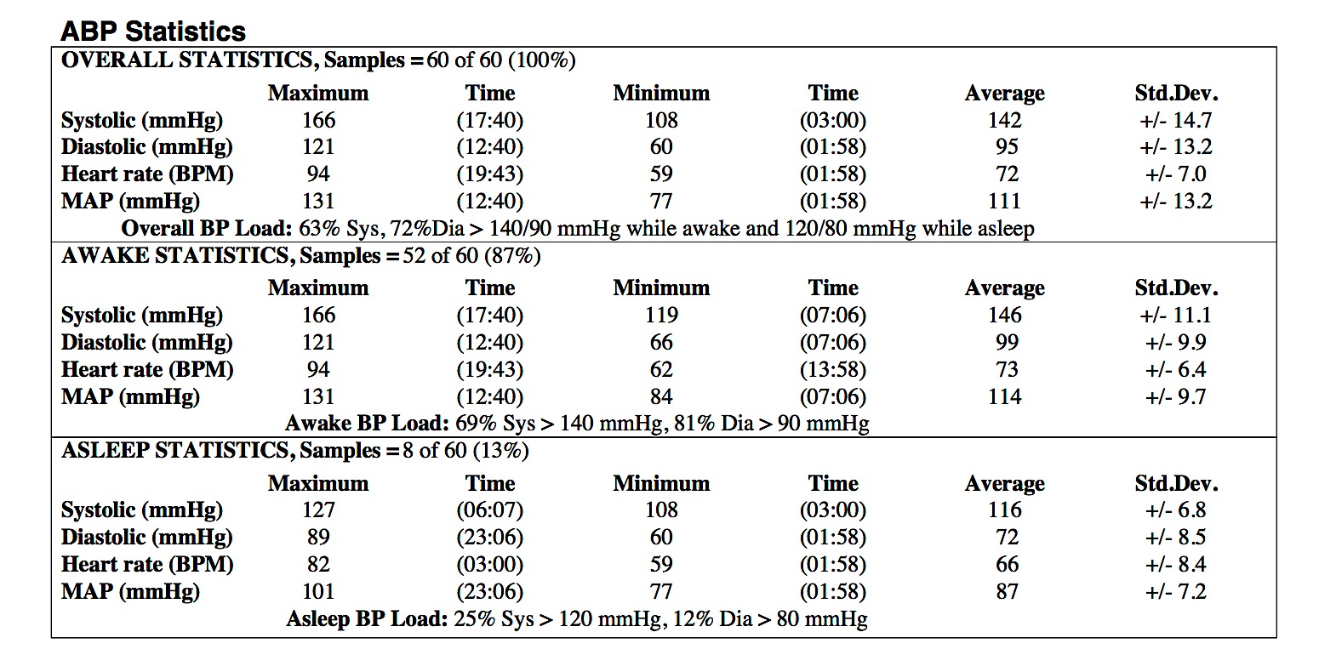

**Clinical interpretation:**

Patient has severe hypertension with night-time dip. Medications being prescribed accordingly. Blood cholesterol levels high. Suggest adjustment to lifestyle and diet to help control.

Follow up ABP needed to check efficacy.

Sincerely,

Dr. MD, M.D.

Mount Sinai

10 Union Square East, Suite 2A  
New York, NY 10003  
212-844-8636